DAILY ONLINE ACTIVITIES SUMMARY

Date: |  | 04-07-2020 |  |  |  |  | Name: | Namratha C
Sem & Sec |  | 8th,A |  |  |  |  | USN: | 4AL16CS056
 |  |  |  | Online Test Summary
Subject |  |  | NA
Max. Marks |  |  | - |  |  | Score |  |  | -
 |  |  |  | Certification Course Summary
Course |  | Introduction to cyber security
Certificate Provider |  |  |  | Great learning |  | Duration |  |  | 5.5 Hrs
 |  |  |  | academy
 |  |  |  | Coding Challenges

Problem Statement: C Program to simulate a simple calculator using switch statement

Status: Solved

Uploaded the report in Github | Yes
If yes Repository name
 | Daily_progress
Uploaded the report in slack | Yes

Online Test Details: (Attach the snapshot and briefly write the report for the same)

Certification Course Details: (Attach the snapshot and briefly write the report for the same)

Coding Challenges Details: (Attach the snapshot and briefly write the report for the same)

- Certification Course Details
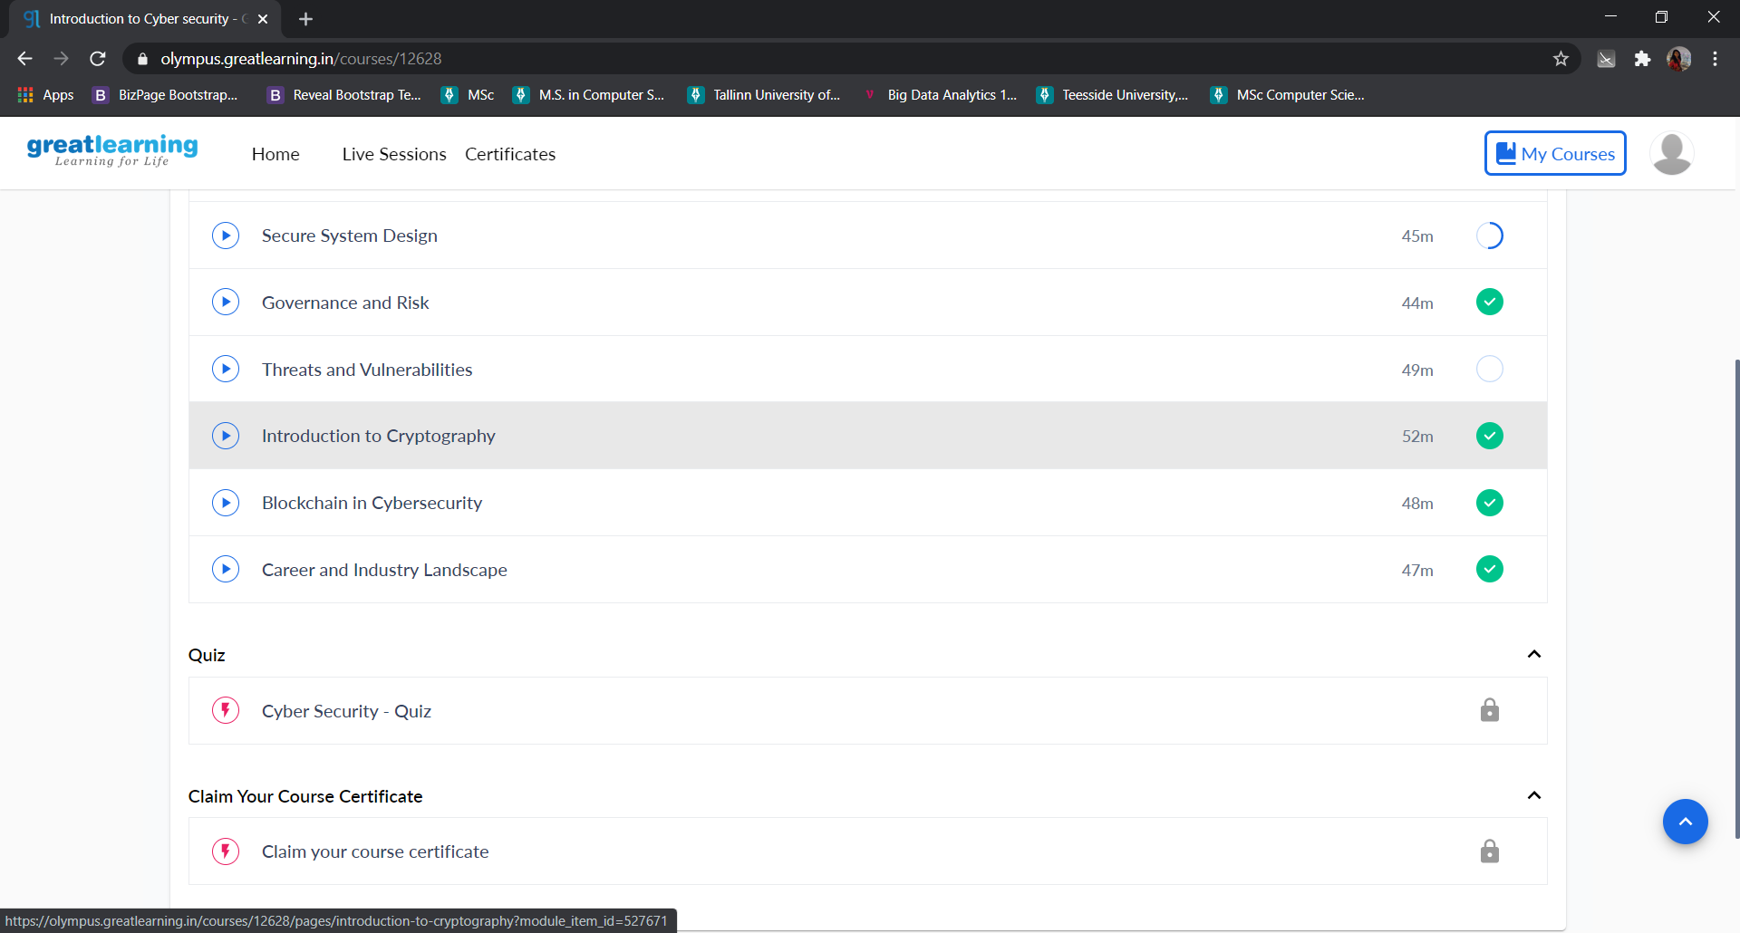

2) Coding Challenges:

#include<stdio.h>

int main(void)
{
int a, b, result;
char op; // to store the operator

printf("Enter an expression: ");
scanf("%d%c%d", &a, &op, &b);

switch(op)
{
case '+':
result = a + b;
break;
case '-':
result = a - b;
break;
case '*':
result = a * b;
break;
case '/':
result = a / b;
break;
}

printf("Result = %d", result);

return 0; // return 0 to operating system
}

